Day 4 — Advanced Java Programming Concepts
Topics
• Arrays
• Strings
• Collections Framework
• ArrayList and HashMap
• Exception handling
• File handling basics
• Introduction to Java Streams
Tasks
• Store and process student or employee records.
• Search for a record by ID or name.
• Sort records by name or marks.
• Handle invalid input using exception handling.
• Practice working with ArrayList and HashMap.

Expected Output
• Java collection-based programs.
• Student/Employee data processing application.

1. What is an Array in Java?
An array is a data structure that stores multiple values of the same data type in a single variable.
Normally, if we want to store five student marks, we might create five separate variables.
int mark1 = 80;
int mark2 = 75;
int mark3 = 90;
int mark4 = 85;
int mark5 = 70;
Instead of creating five variables, we can use an array.

2. Why do we use arrays?
Arrays are useful because they:
- Store multiple values using one variable.
- Make data easier to manage.
- Allow quick access to elements using indexes.
- Work well with loops to process large amounts of data.
- Help in implementing searching, sorting, and other algorithms.

3. Syntax of an array
dataType[] arrayName = new dataType[size];

4. Types of arrays in Java
Java arrays are commonly classified into three types:
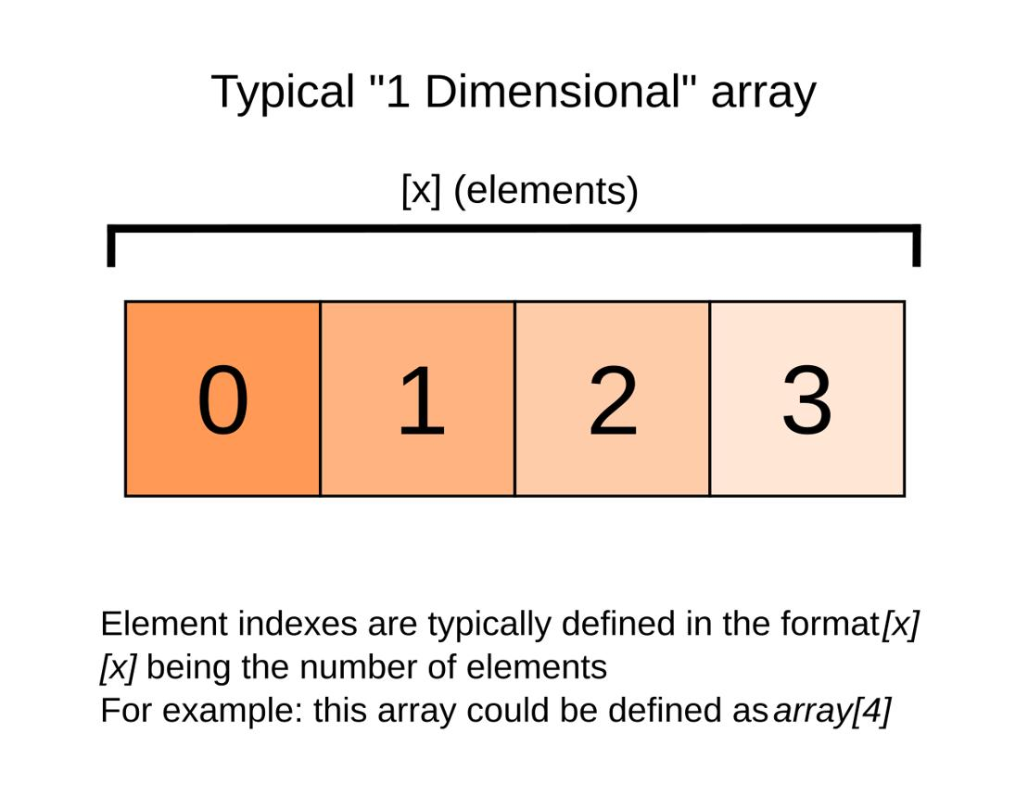
1. One-dimensional array
Stores elements in a single sequence.
Example: int[] numbers = {10, 20, 30};
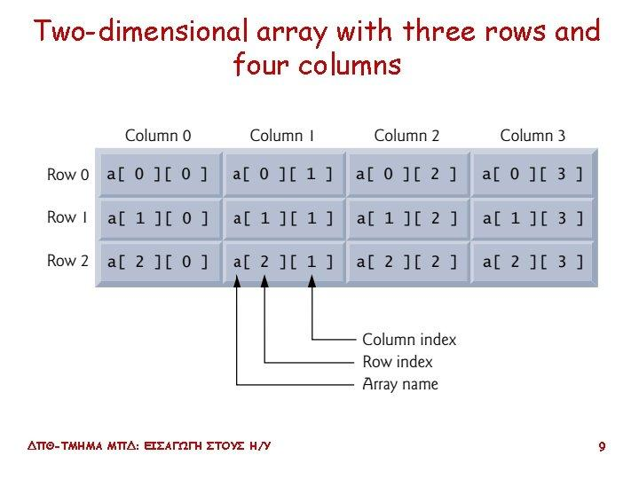
2. Two-dimensional array
Stores elements in rows and columns.
Example: int[][] matrix = {{1, 2}, {3, 4}};
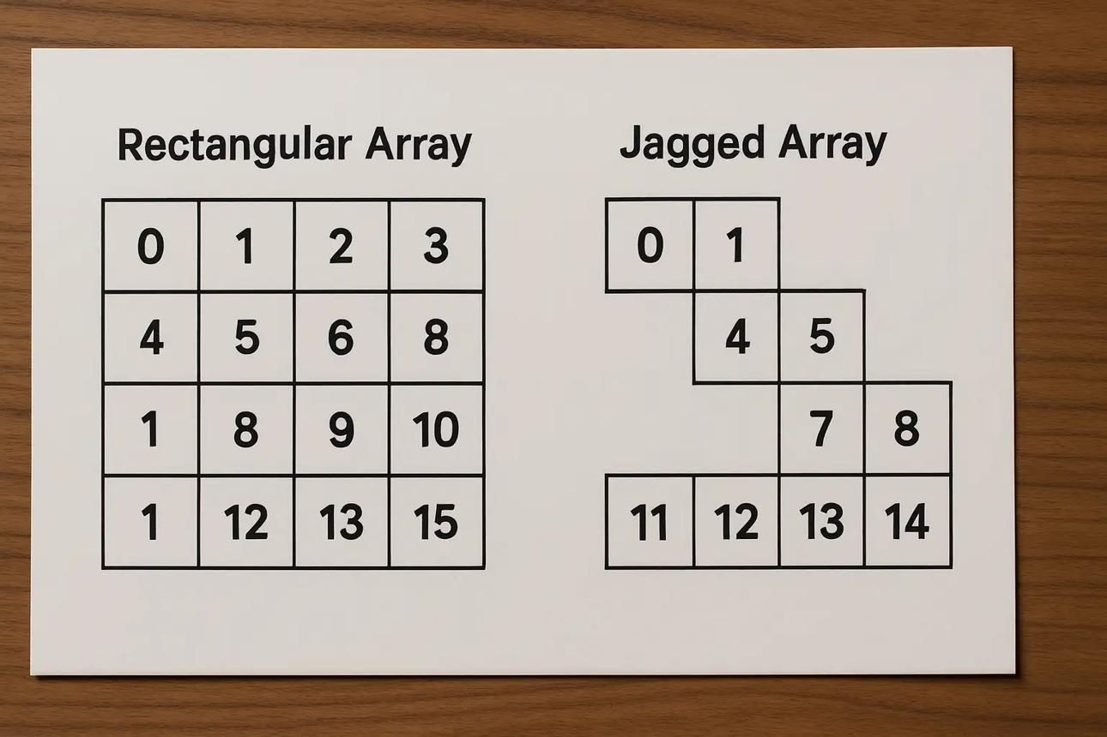
3. Jagged array
A two-dimensional array where rows can have different lengths.
Example: int[][] data = {{1, 2}, {3, 4, 5}};

